**Fox, Ethel Carrick (1872–1952)**

Ethel Carrick Fox was British trained but married Australian artist Emmanuel Phillips Fox in 1905 and spent her five-decade career closely associated with Australian artists. Although based in Paris she frequently visited Australia between 1908 and 1952. By c.1910 she was surprisingly high profiled and active in Paris for an English speaking female artist, being elected a societaire of the Salon d’Automne in 1911 and serving on its selection committee in 1912. She was active in organisations promoting women artists in Paris, being vice president of the Union des Femmes Peintres et Sculpteurs in 1912, and exhibited with progressively orientated groups such as the Libre Aesthetique in Brussels, 1909. The coming of World War One diminished her career internationally but until her death in 1952 she was renowned in Australia for her cosmopolitan outlook, her work in public and patriotic fundraising, her activities as a de agent facto in Paris for Australian-based artists and for setting an example as an enterprising woman artist, painting and exhibiting widely whenever she was in the country. On her first visit to Australia in 1908, the women artists of Melbourne held a reception in her honour. During this visit and her second visit in 1913-16, she was technically the most progressive woman artist working in Australia and was frequently interviewed by reporters regarding her opinions of art in Paris.



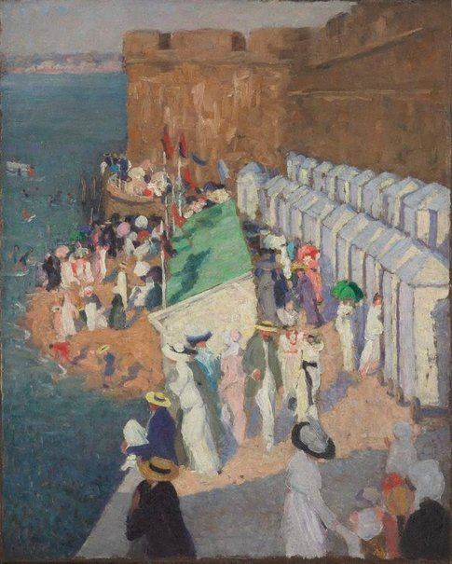

Ethel Carrick Fox, *La marée haute à Saint-Malô (High tide at St Malô)*, ca. 1911-12, oil on canvas, 79 x 64 cm, Art Gallery of NSW, Australia.

Having studied at the Slade School, stylistically Fox demonstrated the efficient professionalism of late Victorian /Edwardian art training and its acceptance of progressive French techniques of realism and mild post-impressionism. A high-keyed fauvist colourist tendency pushed her work further as did her tendency to emphasise brushstrokes and the observed geometry of architecture and engineering features in the landscape. Works produced in Algeria and Morocco in 1911 have an arbitrary sharpness of form and tonality and an emphasis on design, underpinned in some works by a cloissonism, seen also in *Manly Beach- Summer is Here*, 1913, a major work that received the Diploma of Honour at the Bordeaux Internationals Exhibition in 1928: her highest public honour. The combined practice of the Foxes in 1900s Paris inverts many gendered stereotypes of the period, as Ethel preferred to work outside the home in the streets of Paris, whilst her husband constructed elaborate scenes of nudes and domestic life. In c.1910-1913, Ethel attracted more attention in a more radical milieu than her husband.

After the death of her husband in 1915, her career perhaps never matched its pre-World War One profile, although in 1919 she worked with the wife of the French President on providing cultural education for allied soldiers in Paris. The Académie de la Grande Chaumière recommended her as a teacher of still life during the 1920s as that subject was not taught at the atelier. She travelled throughout Europe, North Africa and India and still painted in France. Some of her most singular later work reflected the impact of the world wars on everyday life. The confiscation and auctioning of the contents, including artworks, of her home that she had formerly shared with her Jewish husband in Paris under the Vichy regime and ensuing attempts at restitution, cast a shadow over the last decade of her life

**References and Further Reading**

Hylton, J. (2000) *Modern Australian Women: paintings & prints 1925-1945*, Adelaide, South. Australia: Art Gallery of South Australia.

Goddard, A. ed. (2011) *Art, love & life: Ethel Carrick & E Phillips Fox*, Brisbane: Queensland Art Gallery.

(A major collection of essays on the life and work of the Foxes by curators and academics. This is the first publication to look at the oeuvres of the couple on an equal and integrated basis and presents fresh and important scholarship. Details and dates of career events and exhibition lists have been corrected, cross checked and refined to a level previously not captured, as neither artist left detailed archival collections.)

Howe, E. (1994) ‘Ethel Carrick Fox: The cheat or the cheated?’ In Maryanne Dever, ed. *Wallflowers and witches: women and culture in Australia, 1910-1945*, St Kucia, Qld.: University of Queensland Press. p. 105-14

(An early feminist study that emphasises family dramas and Carrick Fox’s exclusion from her in laws’ family circle at the expense of discussion of her artwork and also predates the strong curatorial revival of interest in Edwardian art which positions the Foxes’ work more securely)

Peers, J. (1997) ‘Ethel Carrick Fox.’ In Delia Gaze ed. *Dictionary of Women Artists* Chicago: Fitzroy Dearborn Publishers. p. 545-546.

(An overview of the artist concentrating on her career as painter and her achievements amongst her contemporaries)

Rich, M and Zubans, R. (1979) *Ethel Carrick (Mrs E. Phillips Fox): a retrospective exhibition*, Geelong, Victoria: Geelong Art Gallery.

(The first curated survey of the Ethel Carrick Fox’s work)

Online resource – from National gallery of Australia’s overview of Edwardian art

http://nga.gov.au/Exhibition/Edwardians/Default.cfm?MnuID=SRCH&ArtistIRN=15171&Alpha=C